2019 National Collegiate
Men’s Water Polo Opening Round Game
Participant Manual

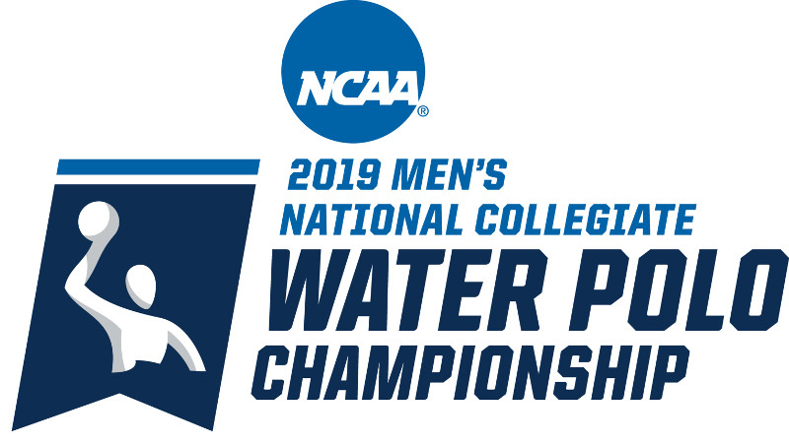

______ vs. ______
Saturday, November 30, 2019
________(venue)_________
______(City, State)_______
___(Game Time)________

Revised 10/15/2019

Table of Contents
Contact Information 2
Schedule of Events 3
Practices 3
Parking/Directions 4
Facility/Campus Maps 4
Tickets 4
Media Relations 4
Visiting Team Locker Room 5
Visiting Team Hotel 5
Drug Testing 5
Pregame Timing Schedule 6
Visiting Team Information Form 7

Contact Information

HOST INSTITUTION

Name | Title | Work phone | Cell phone | Email
 | Director of Athletics
 | Team Administrator
 | Tournament Manager
 | Head Men’s Water Polo Coach
 | Facility Manager
 | Sports Information Director
 | Head Athletic Trainer
 | Ticket Operations

OTHER IMPORTANT NUMBERS

Name | Title | Work phone | Cell phone | Email
 | (University Police)
 | (Nearest Hospital)
 | (Hotel Sales Manager)

VISITING INSTITUTION

Name | Title | Work phone | Cell phone | Email
 | Director of Athletics
 | Head Men’s Water Polo Coach
 | Team Administrator
 | Sports Information Director
 | Head Athletic Trainer

NCAA CONTACTS

Name | Title | Work phone | Cell phone | Email
 | Site Representative
Randy L. Buhr | Championship Administrator | 317-917-6716 | 317-966-7306 | rlbuhr@ncaa.org

Schedule of Events
Friday, November 29

Start Time | End Time | Activity
 |  | Include any institution activities scheduled
 |  | _____ closed practice
 |  | Administrative meeting
 |  | _____ closed practice

Saturday, November 30

Start Time | End Time | Activity
 |  | Include any institution activities scheduled
 |  | Gates open to public
 |  | Captains/Officials meeting
 |  | Warm-up
 |  | ____ vs. _____ Game

Practices

_____ will practice from ____ to ____ Friday, November 29.

_____ will practice from ____ to ____ Friday, November 29.

All practice sessions will be closed. Observers may be allowed by permission of the head coach. Any questions regarding practice should be directed to ________.

Parking/Directions

(Please include information for team buses, vans and spectator parking. In addition, also include directions to the venue.)

Facility/Campus Maps

[Please include map(s) showing parking areas and main streets, team entrances, media entrances, spectator entrances, locker rooms, etc.]

Tickets

Tickets may be purchased…. (describe ticket operations)

Ticket Prices
Adults: $___
Students/Children: $___
*All seating will be General Admission

Should you have any questions concerning the game-day ticket procedures, please direct all inquiries to _______. Ticket office hours are _____. The ticket office will open ___ hours before game time.

Media Relations

All media arrangements, credential requests and postgame interview procedures should be coordinated through the men’s water polo sports information director, ____________________.

Visiting Team Locker Room

_____ will use the ________ locker room, located ________. Towels and (specify hospitality items) will be provided. Please direct any other special requests to _____________.

Visiting Team Hotel

Rooms have been reserved at __________________________. The room rate is $____ + appropriate taxes. Please direct hotel questions to:

Hotel Name
Hotel Address
Hotel Phone
Sales Manager Name and Contact Information (including work phone, cell phone and email address)

Drug Testing

Student-athletes may be subjected to drug tests in accordance with NCAA Bylaws 18.4.1.5 and 31.2.3.

Pregame Timing Schedule

Time Actual
Allotted Time Protocol Game Clock_____
______ Start Clock 60:00
05:00 ______ Captains/officials meeting 60:00
45:00 ______ Competition course and game 55:00
balls available for warm-up
4:00 ______ Clear pool, teams to bench area 10:00
1:00 ______ Introduce team in white caps 06:00
1:00 ______ Introduce team in dark caps 05:00
0:15 ______ Introduce referees 04:00
1:45 ______ National anthem 03:45
2:00 ______ Final team huddle 02:00
______ Reset clock and begin game 00:00

PREGAME PROTOCOL

(Please provide details of the opening ceremony. An example is provided here.)

When the first buzzer sounds, both teams are to clear the pool and report to the designated staging areas. The team with the dark caps will line up in reverse cap order (largest number first) with the captain at the end of the line. The team with the white caps will line up with the captain first, followed by team in cap order. The teams will march from the staging area to the north end of the pool and stand facing the pool. The two officials will position themselves between the two captains following the march-in. Student-athletes must be in official uniform (robes or sweats) with caps on. At this time, both teams will have their entire team announced, in order of cap numbers, starters will be announced once the teams are in the water just before the start of the game. Team with white caps (visiting team) will be announced first, followed by the team with dark caps (home team). Officials are then announced. After the national anthem, the two captains of the teams will shake hands and the teams will exit to their benches.

Visiting Team Information Form

Institution: ___________________________________________________________________

Contact information:

Name | Title | Work phone | Cell phone | Email
 | Director of Athletics
 | Head Men’s Water Polo Coach
 | Team Administrator
 | Sports Information Director
 | Head Athletic Trainer

Anticipated arrival in host city:
Date: _________________________________________________________________

Time: _________________________________________________________________

Mode of transportation: Air Bus Van/cars

How many parking spaces will be required for your team?
______ buses
______ vans
______ cars

Confirm Friday practice time: _____________________

